Student Support Services
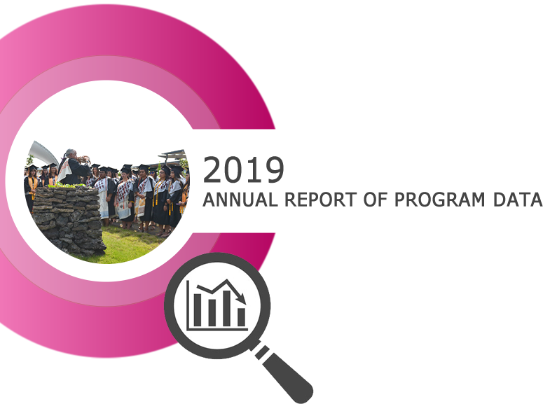

1. Program Description
Statement and brief description of the program including a listing of the program level Student Learning Outcomes (SLOs) and/or Service Area Outcomes (SAOs).

2. Analysis of the Program
Strengths and weaknesses in terms of demand, efficiency, and effectiveness based on an analysis of the Quantitiative Indicators and surveys (located in the Appendix).

3. Program Student Learning Outcomes
- List of the Program SLOs/SAOs
- Program SLOs/SAOs that have been assessed
- Assessment Results
- Changes that have been made as a result of the assessments

4. Action Plan
Include how the actions within the plan support the collegeʻs mission.

5. Resource Implications
(physical, human, financial)

Appendix: Community College Survey of Student Engagement (CCSSE)
Data last updated: 10/4/2019
# | Community College Survey of Student Engagement (CCSSE) | Survey Year  2014 | Survey Year  2016 | Survey Year  2018 *
1. | Support for Learners Benchmark (Percentile) | 70 | 0
2a. | Academic Advising – Frequency | 1.79 | 1.88 | 1.45
2b. | Academic Advising – Satisfaction | 2.26 | 2.38 | 1.46
2c. | Academic Advising – Importance | 2.58 | 2.56 | 2.62
3a. | Career Counseling – Frequency | 1.59 | 1.55 | 0.82
3b. | Career Counseling – Satisfaction | 2.11 | 2.18 | 1.42
3c. | Career Counseling – Importance | 2.43 | 2.42 | 2.45
4a. | Job Placement Assistance - Frequency | 1.31 | 1.36 | 0.24
4b. | Job Placement Assistance – Satisfaction | 1.84 | 2.01 | 1.08
4c. | Job Placement Assistance – Importance | 2.20 | 2.21 | 2.09
5a. | Financial Aid Advising - Frequency | 1.86 | 1.83 | 0.99
5b. | Financial Aid Advising – Satisfaction | 2.18 | 2.26 | 1.37
5c. | Financial Aid Advising – Importance | 2.54 | 2.48 | 2.50
6a. | Student Organizations – Frequency | 1.41 | 1.49 | 0.63
6b. | Student Organizations – Satisfaction | 1.99 | 2.17 | 1.33
6c. | Student Organizations – Importance | 2.01 | 2.16 | 2.05
7a. | Transfer Credit Assistance - Frequency | 1.41 | 1.56 | 0.54
7b. | Transfer Credit Assistance – Satisfaction | 1.97 | 2.15 | 1.35
7c. | Transfer Credit Assistance – Importance | 2.28 | 2.25 | 2.23
8a. | Services for People with Disabilities – Frequency | 1.31 | 1.39 | 0.22
8b. | Services for People with Disabilities – Satisfaction | 2.12 | 2.14 | 1.21
8c. | Services for People with Disabilities – Importance | 2.20 | 2.24 | 2.18
* 2018 uses different scales, therefore only Importance is comparable.

